**EC2 Task’s**

Q.1) Create a new EC2 instance with a specific Amazon Machine Image (AMI) of your choice.

Choose an appropriate EC2 instance type based on your application's requirements.

Configure security groups to allow specific inbound and outbound traffic.

Assign an Elastic IP address to the instance for a static public IP (if needed).

Connect to the instance using SSH or RDP, depending on the operating system.

🡺

Step 1 :-

Firestly loggin aws account and go to ec2 service. 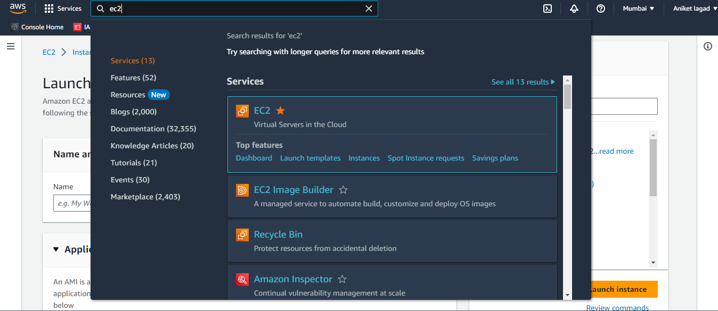

Step 2:-

Now select instance option and then click on launch instances option to launch a instance.

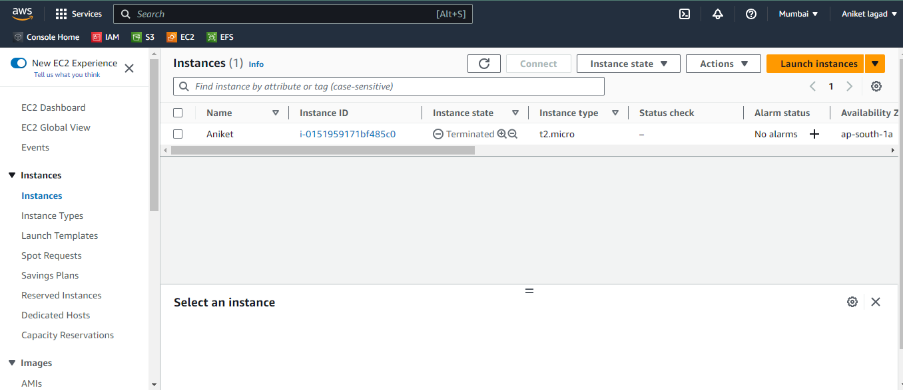

Step 3:-

Now gave a name to instance as u want. 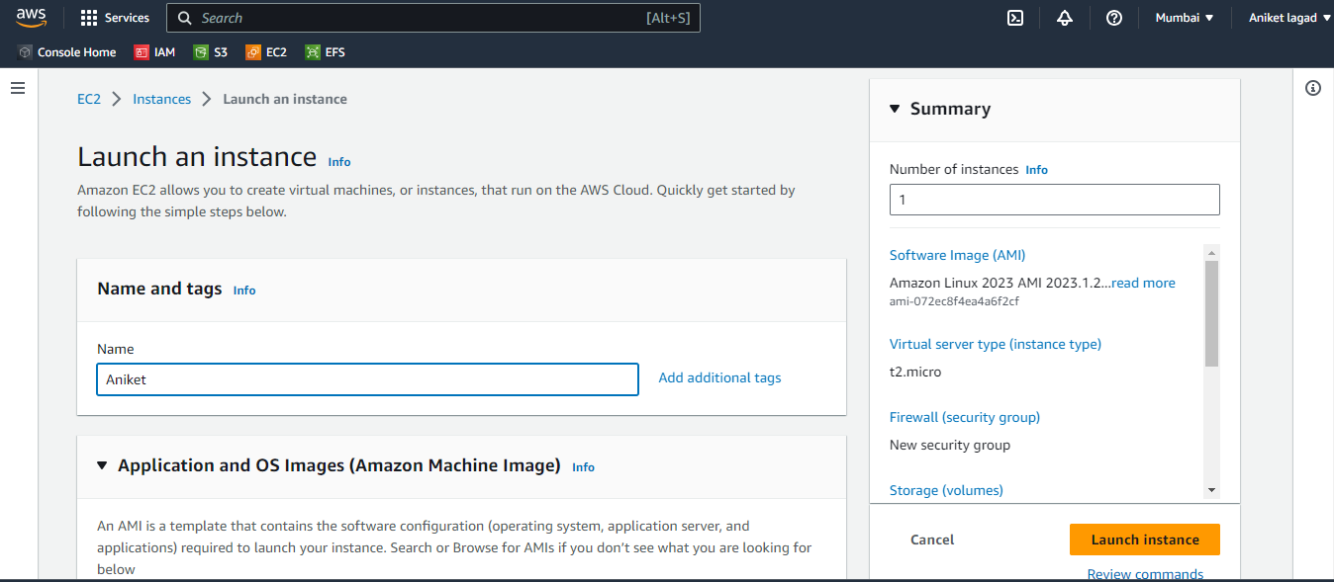

Step 4:-

As per question select any amazon machine image(AMI) as you like.

Iam selected SUSE Linux image.Its user name is “ec2-user or root”.

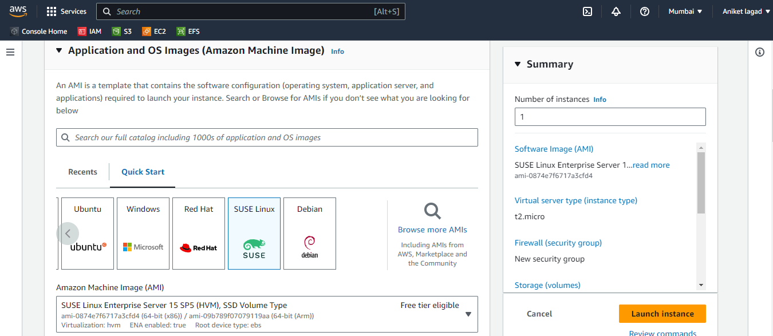

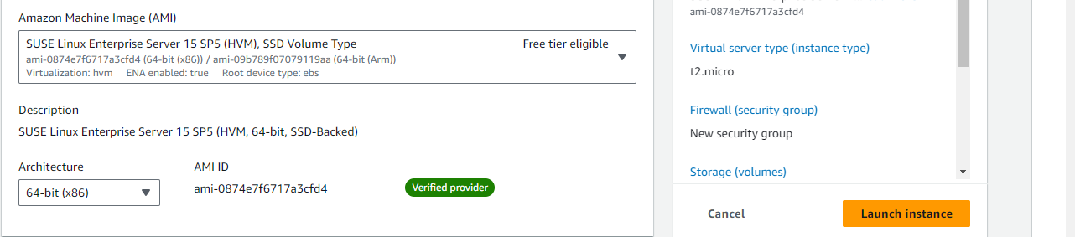

Step 5:-

Now select instance type we usually use t2.micro because its free but if you want to choose then u can choose any other type.

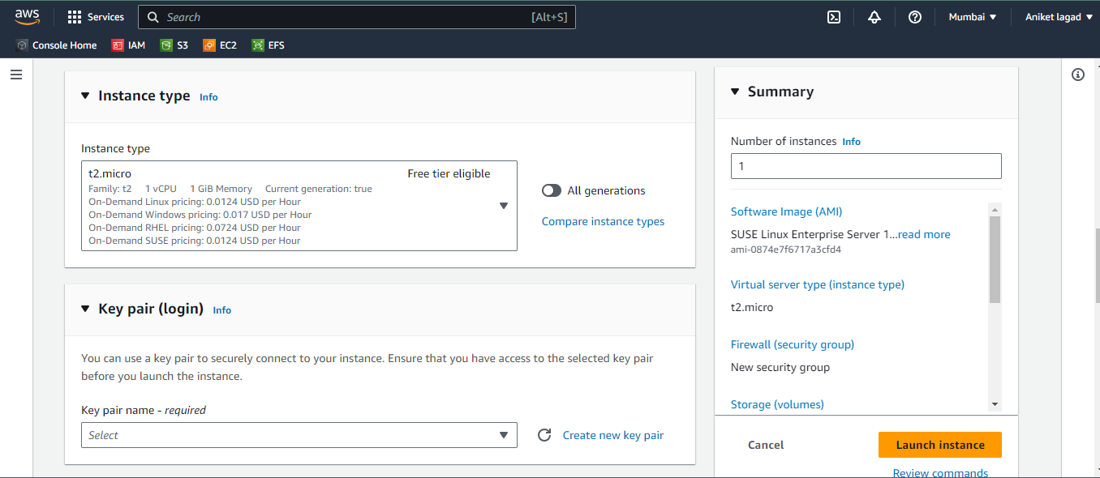

Step 6:-

After that create new key pair or u can select your key.

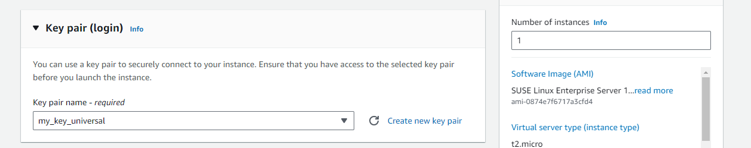

Step 7:-

Now next add in security group if u want to add in your already created security group or u can select on create security group and by default get it new security group.i am choose my existing security group. And after that launch instance.and your instance is ready.

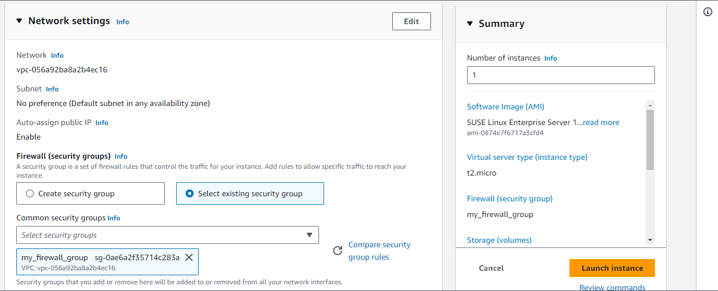

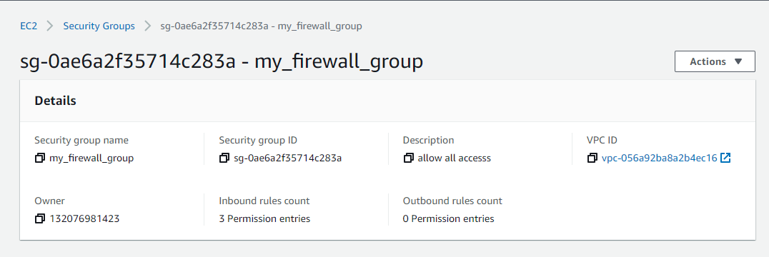

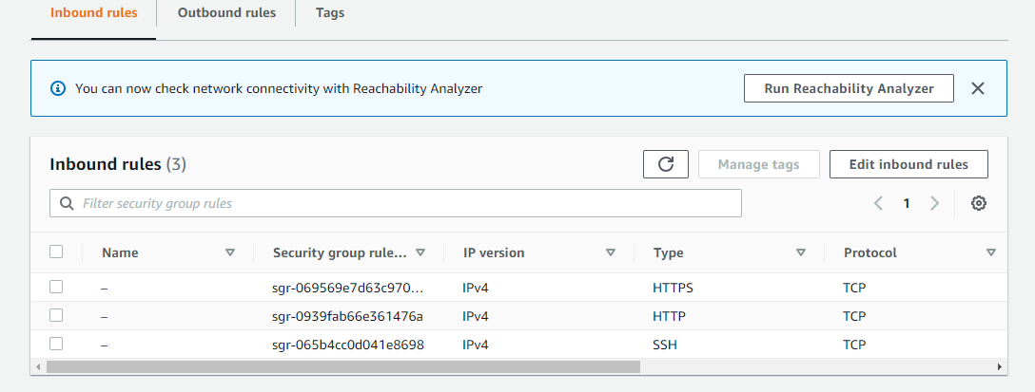

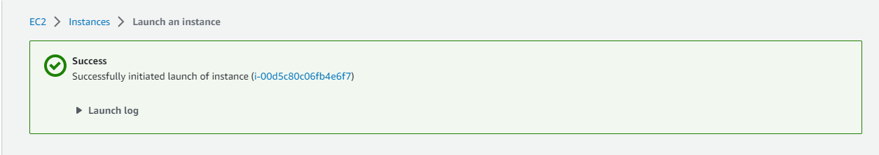

Step 8:-

Now you want to gave it elastic ip address as per question. So u will see left side network and security option and in that you can see elastic ips click on it. And next click on allocate elastic ip address.

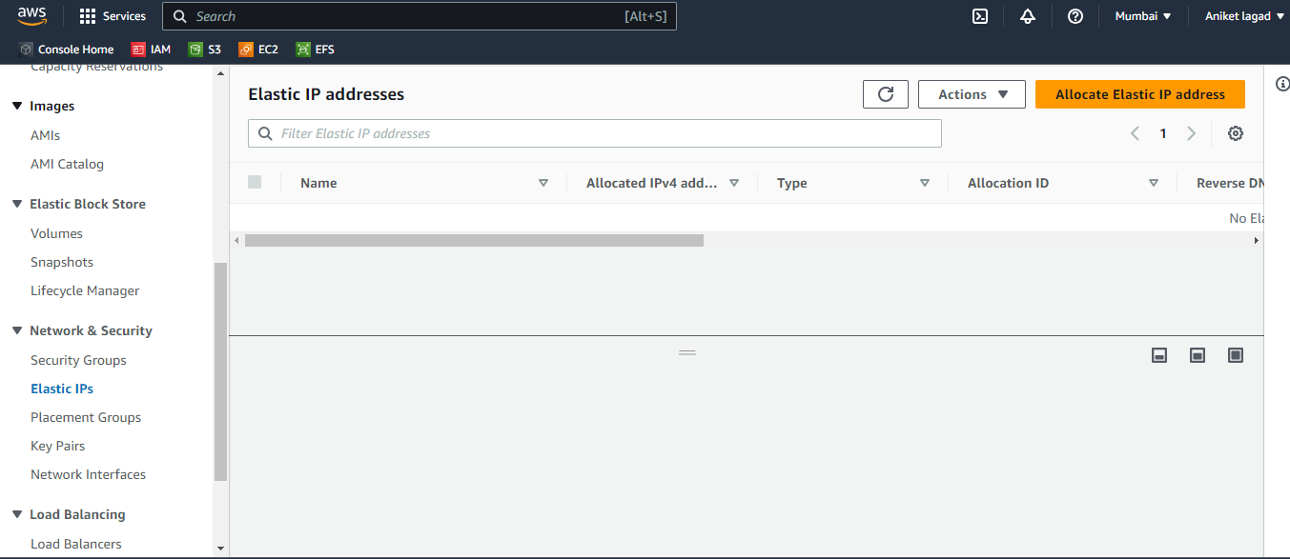

Step 9:-

Now gave it a network border group name and next leave it by default option and click on allocate.

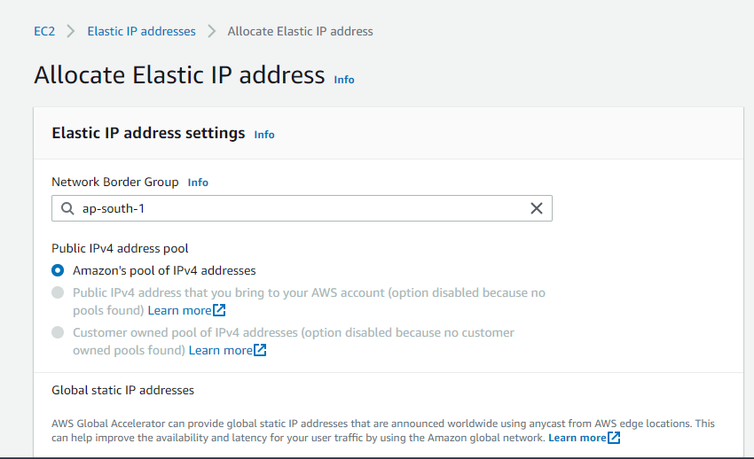

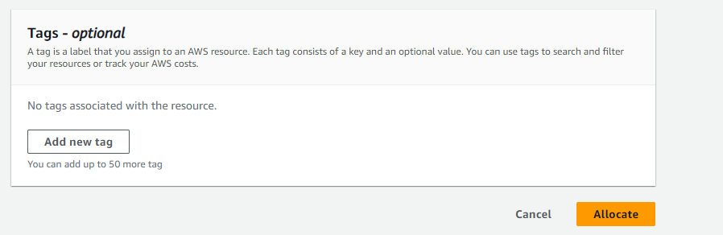

Step 10:-

Now select that elastic ip addresses and click on actions and then associate elastic ip address.

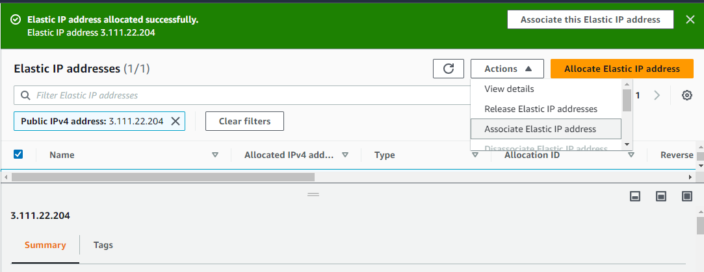

Step 11:-

Next you will go to next screen and there will be you will see resource type choose the instance because we want to create ip address directly apply to instance so select instance.

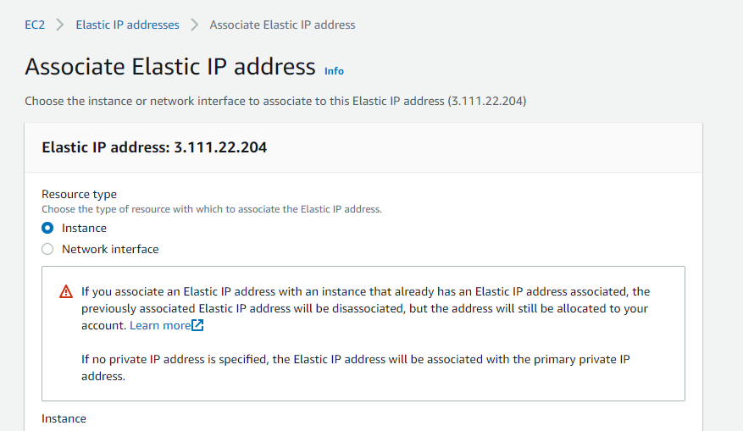

Step 12:-

After that select instance and next gave it private ip address. And next click on associate and instace have get a elastic ip address.

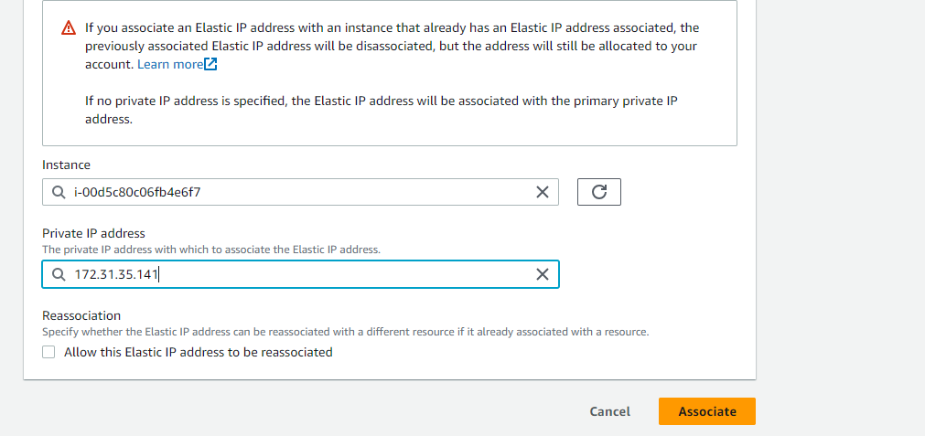

Step 13:-

And you see in following elastic ip address was assigned.

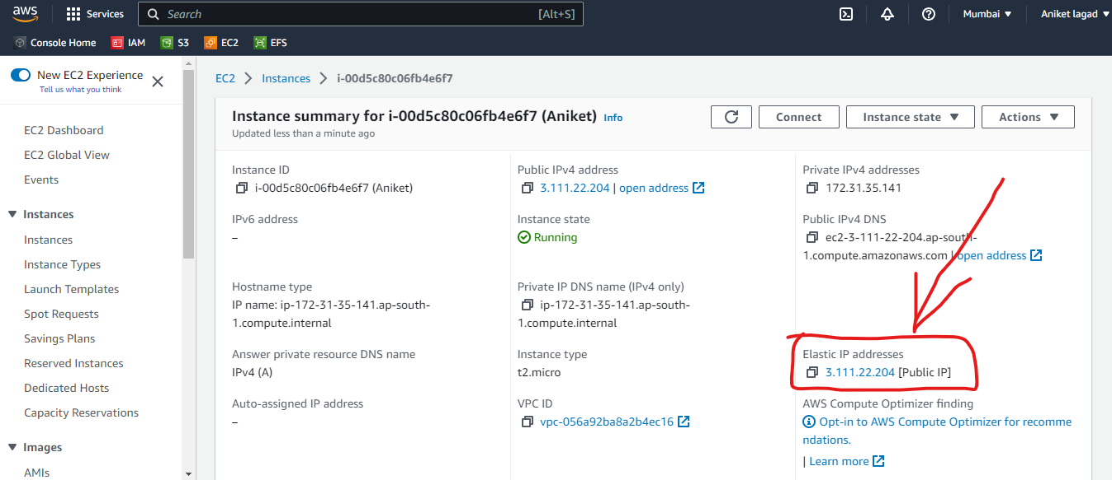

Step 14:-

Now you want get that instance’s access on any third party app by SSH or RDP. So I am go to mobaxtrem third party app and in that you will see left side and top corner session option click on that and next on SSH and then in remote host column ip address and in specify username column ec2-user name or root and next select on advanced SSH settings and in that select use private key and click on ok and you will get a remotely access of instance.

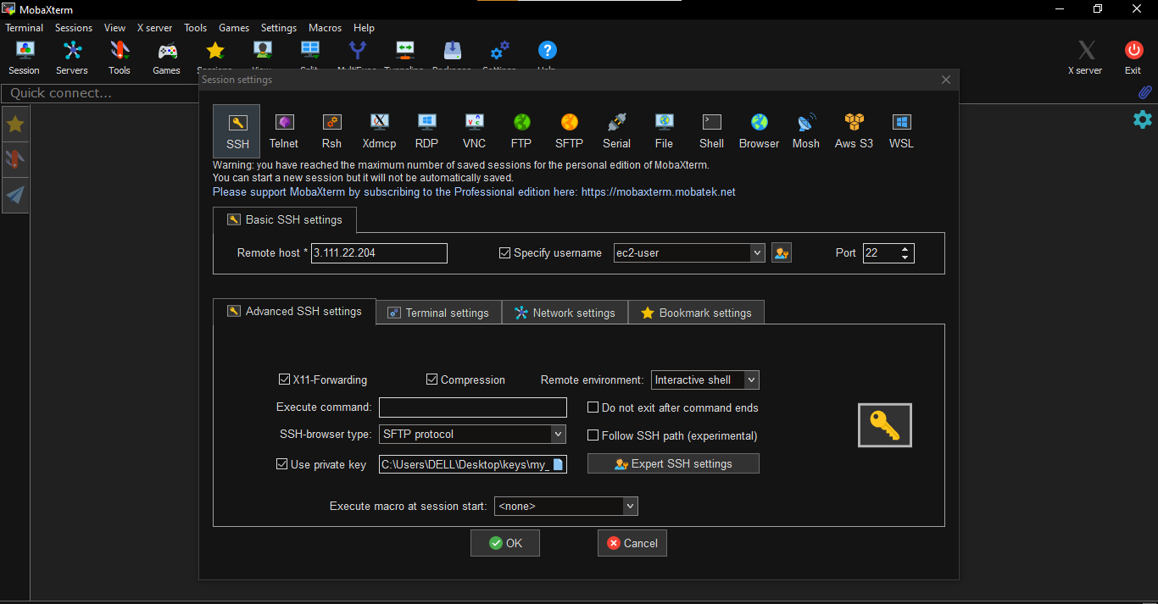

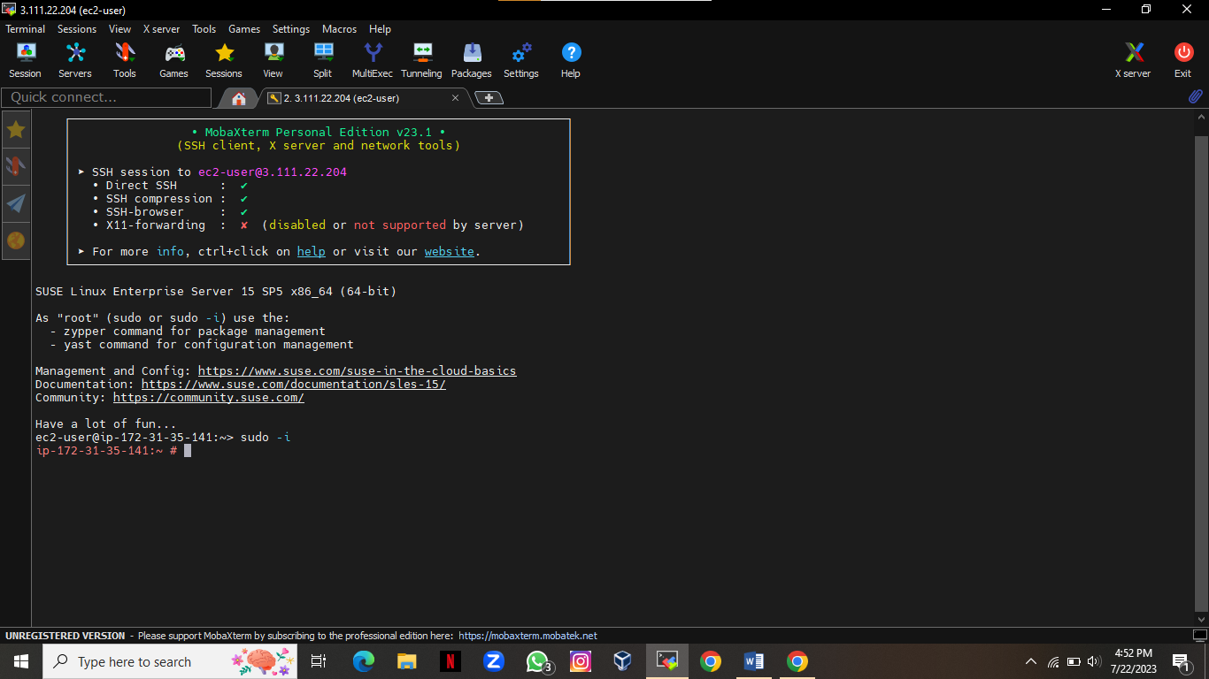

Q.2) Creating and Customizing an AMI:

Launch an EC2 instance based on an existing AMI.

Install necessary software packages and configure the instance according to your application needs.

Create a new custom AMI from the configured EC2 instance to capture the changes made.

Ensure that the custom AMI is private and securely stored.

🡺

Step 1:-

First of all login to aws account and go to ec2 service.

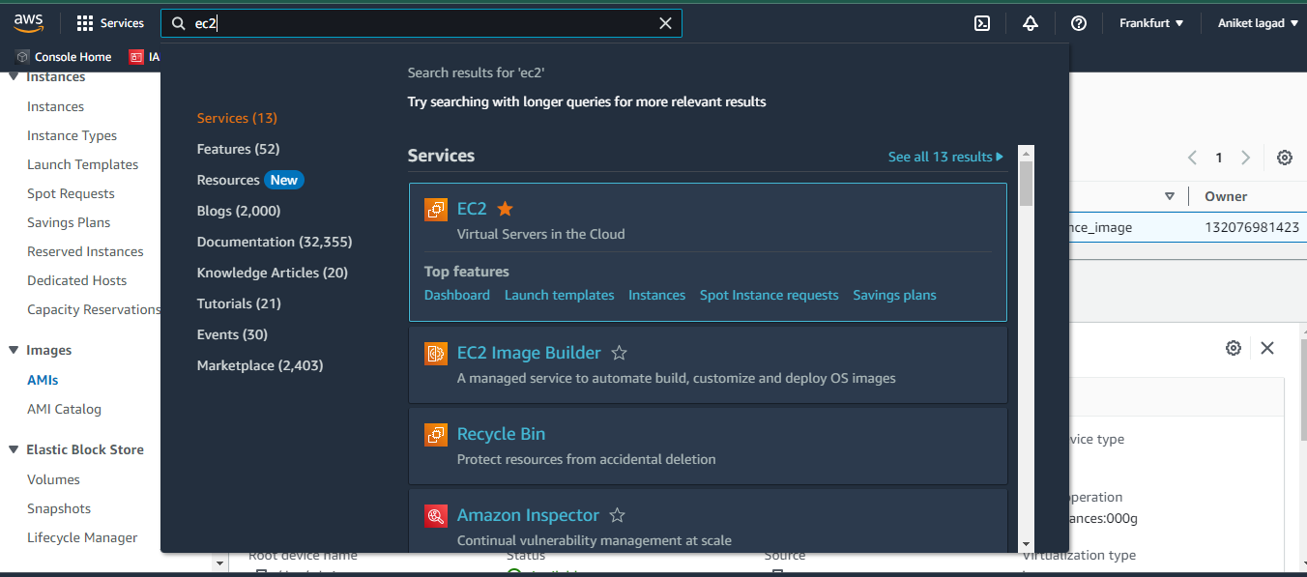

Step 2:-

After that go to images option and in that sub option you see AMIs option click on AMIs.Now you will see the all images created by you. I have one image of my instance. Select that image and click on launch instance from AMI.

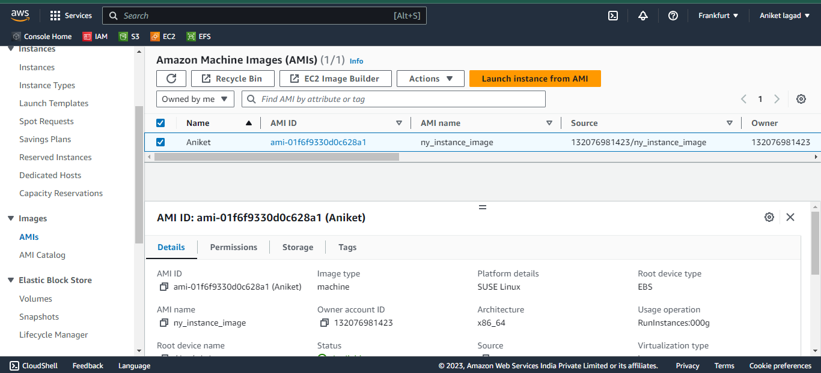

Step 3:-

Now will u want to launch ann instance by that image gave a instance name.

After that scroll down.

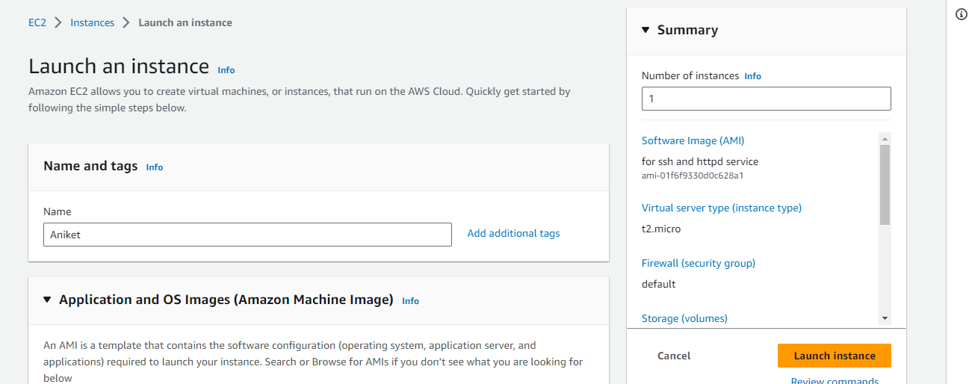

Step 4:-

Now u will see the image which you have selected to launch form AIMs option if it is ohk then go downward or not see your image then select it. After that select a instance type which you want to and then select key pair and next security group select and launch instance .

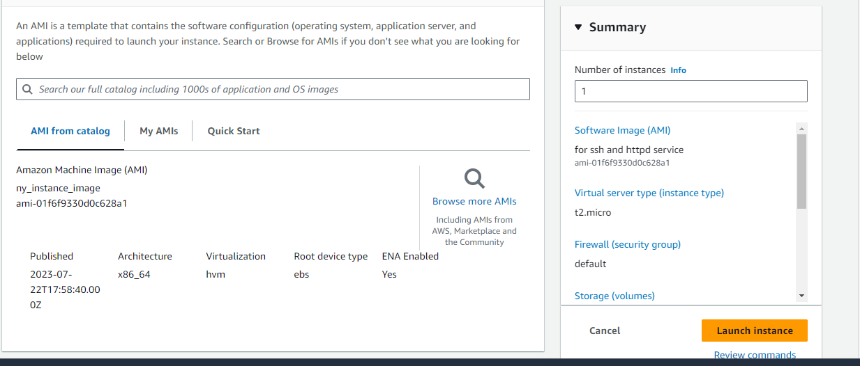

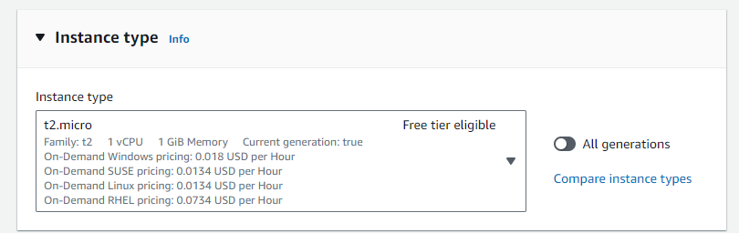

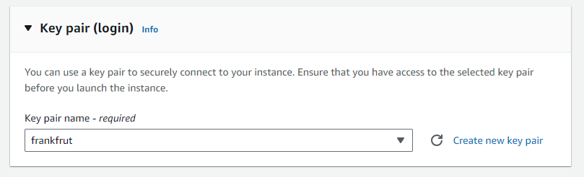

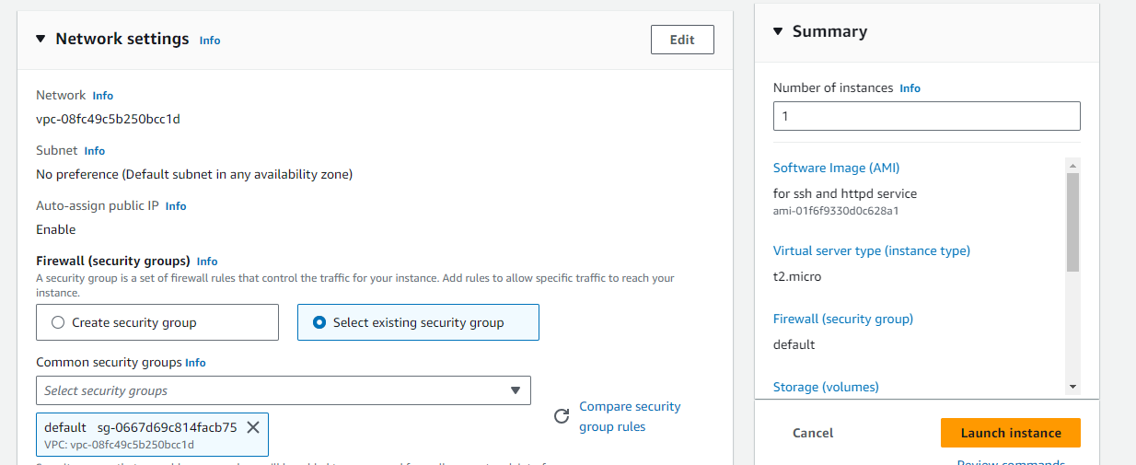

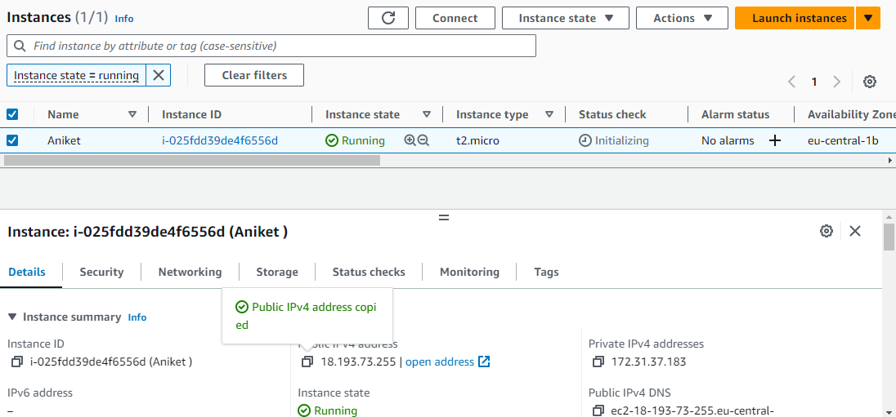

Step 5:-

Now go to third-party app to get remotely access of your instance. For get access of your instance copy your instance’s public ip.



Step 6:-

Now you have to put public ip ,specify username and then private key and you will get access of your instance.

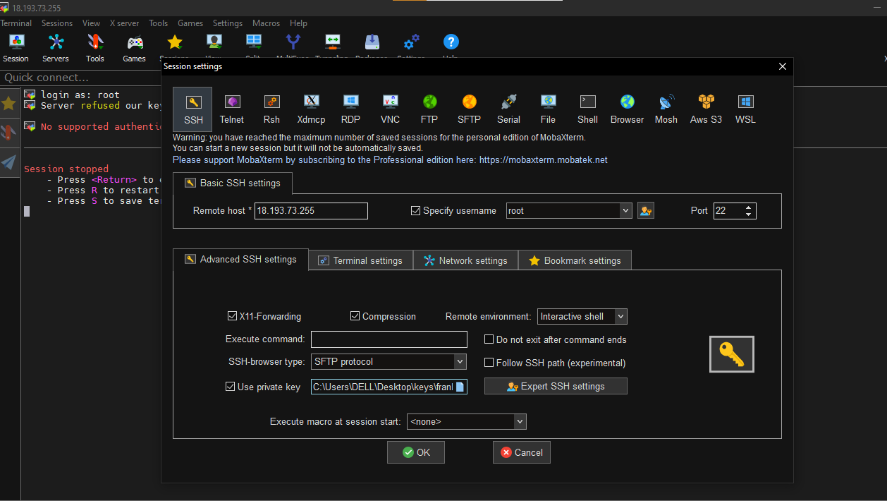

Step 7:-

Now you have get access of instance on third-party app then install a service httpd for hosting and then go back to aws console.

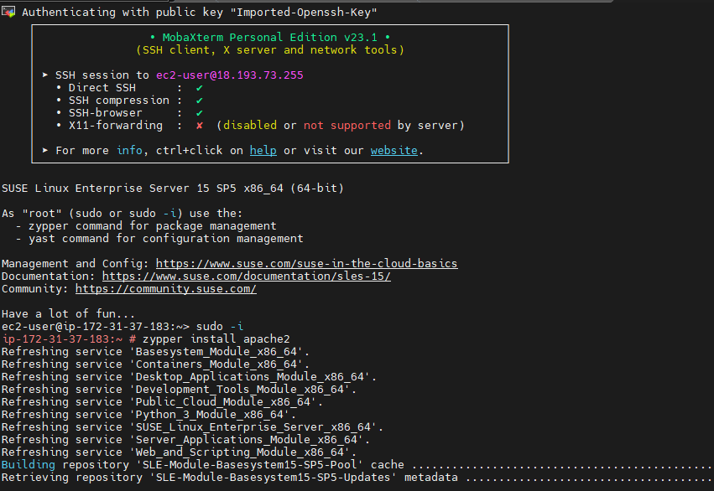

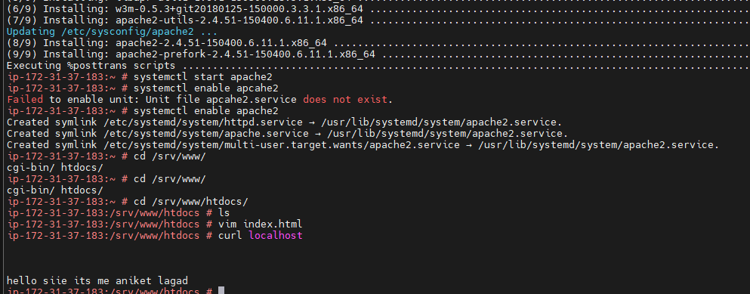

Step 8:-

Now select instance on aws console ec2 service. And next click on actions and downward you will see the iamge and template select it and next click on create mage.

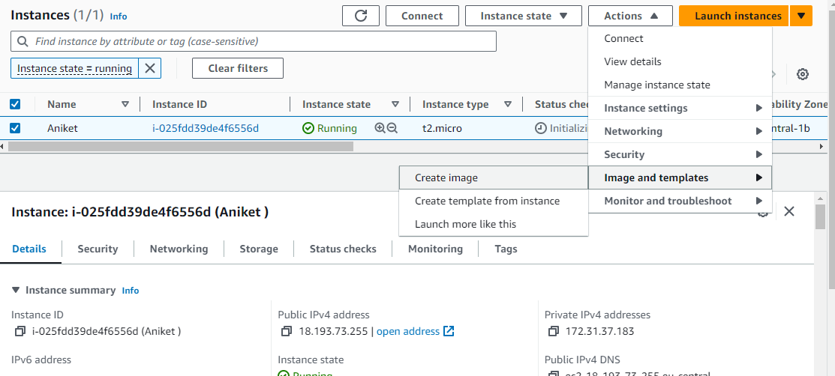

Step 9:-

Now create its image by see following steps.Gave a image name and the its description and next if you want to add extra volume then you can add it. And next select image and snapshot together or separately. And next create its image and your image is securely create means your instance backup is ready.

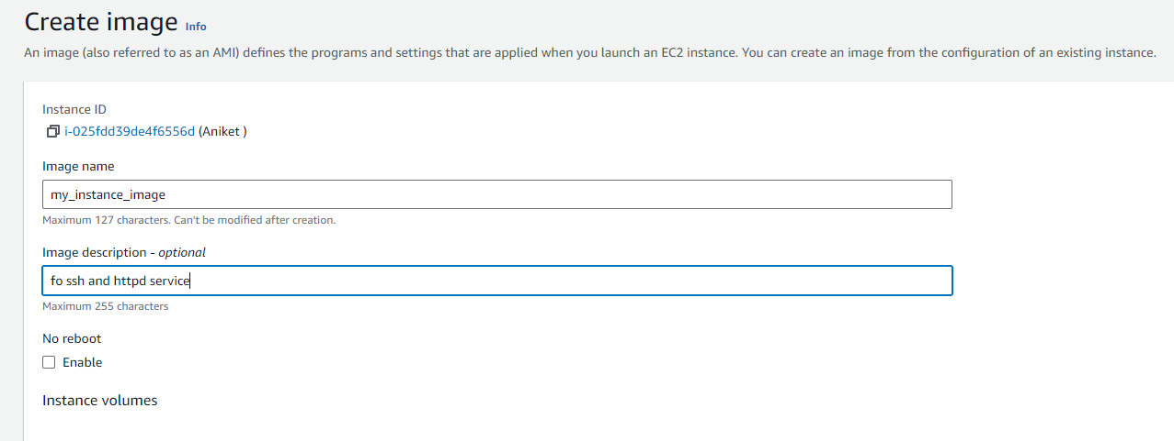

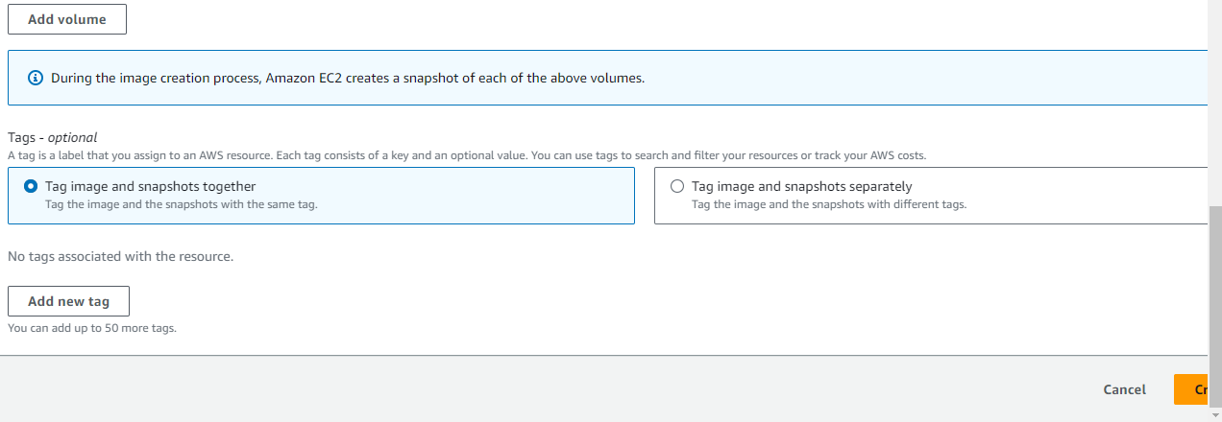

Step 10:-

See here in following image your instance is securely backup in image AMIs.

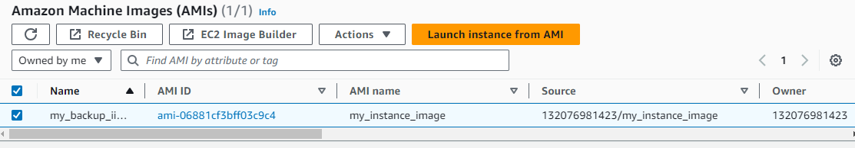

Q.3) Setting up EBS Volumes:

Attach an additional EBS volume to an existing EC2 instance.

Format and mount the EBS volume to make it usable as additional storage.

Test the persistence and data integrity by storing and retrieving data from the attached EBS volume.

🡺

Step 1:-

Loggin to aws account and go to ec2 service.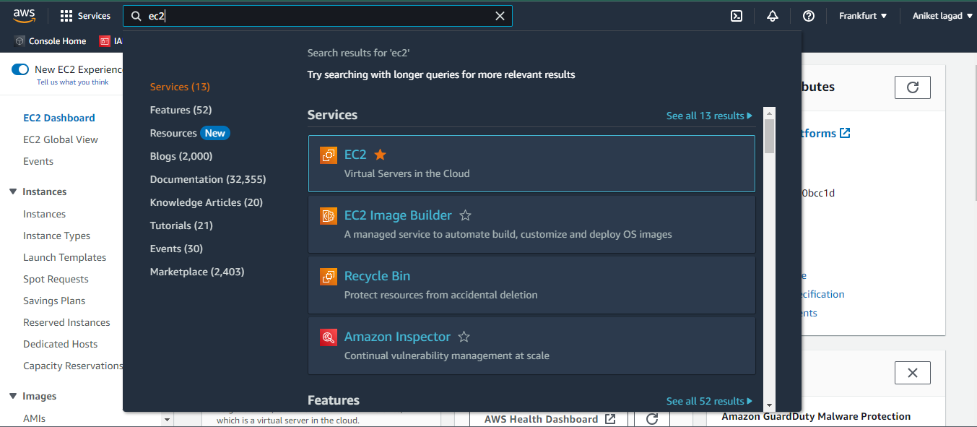

Step 2:-

Now you have to create a volume to attach to the extra volume to your existing instance.

So click on elastic block store means EBS option and then click on create volume.

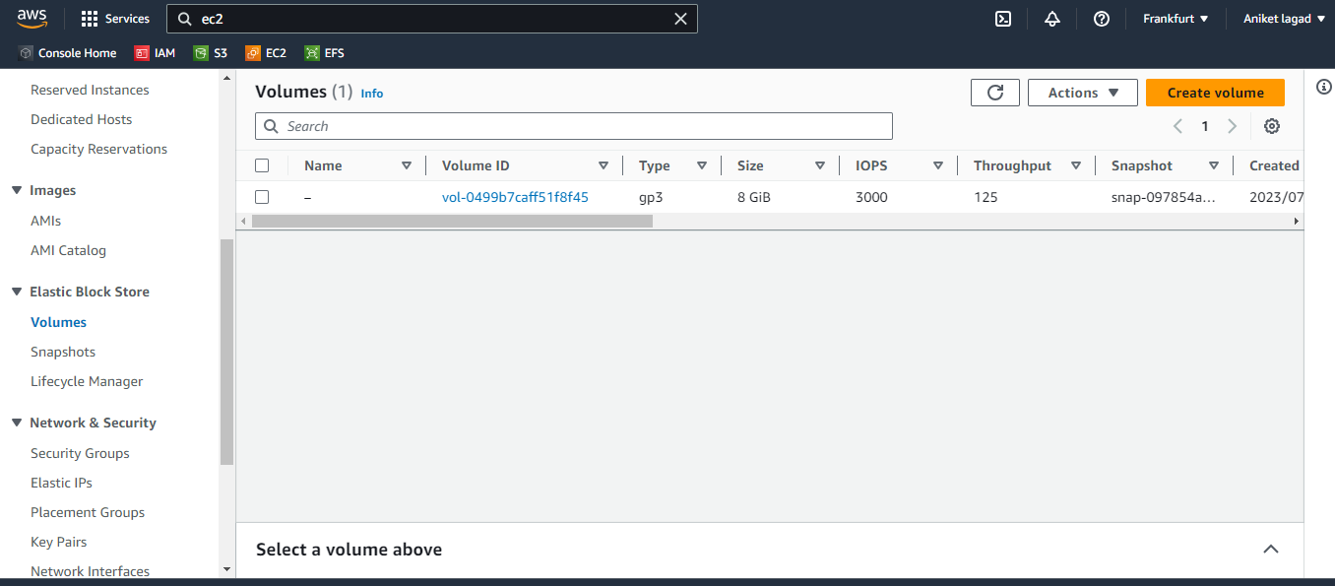

Step 3:-

Now you see the volume setting to create volume. Firstly select volume type I am selected general purpose SSD (gp2) and next select how much you want to add space to it I am selected 10 GB.

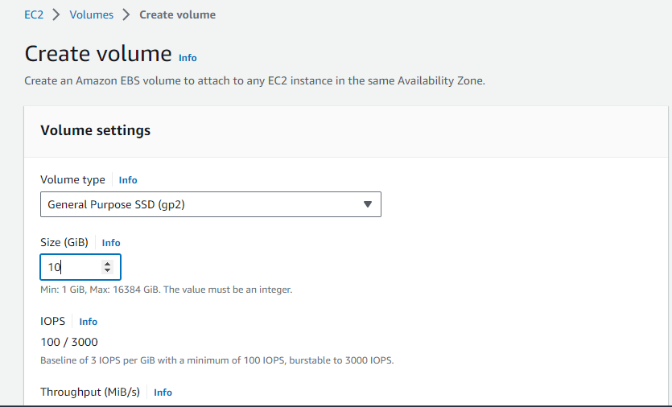

Step 4:-

Next leave it all option as it is and next select availability zone option and create volume in which availability zone your instance was available. And after that if you want to add existing snapshot it means available volume select it.so I am leave as it is and then create volume. And your volume is ready.

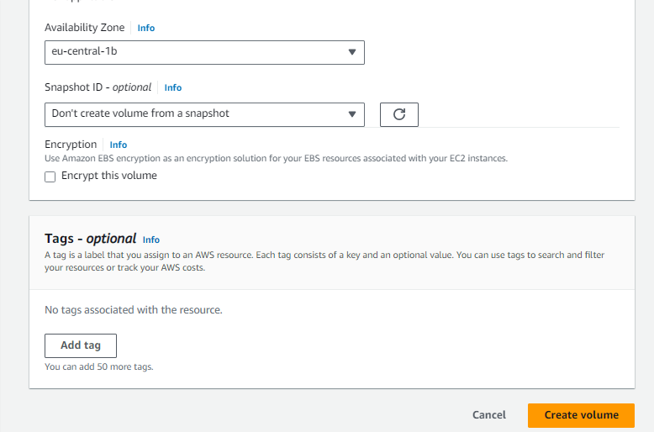

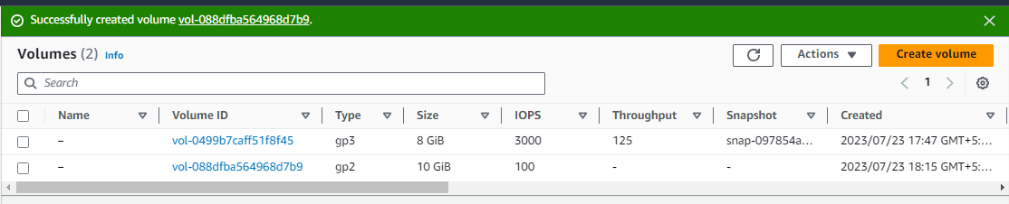

Step 5:-

After that attach your new created volume to instance. Click on actions option and then click on attach volume . Now attach volume and click on attach.

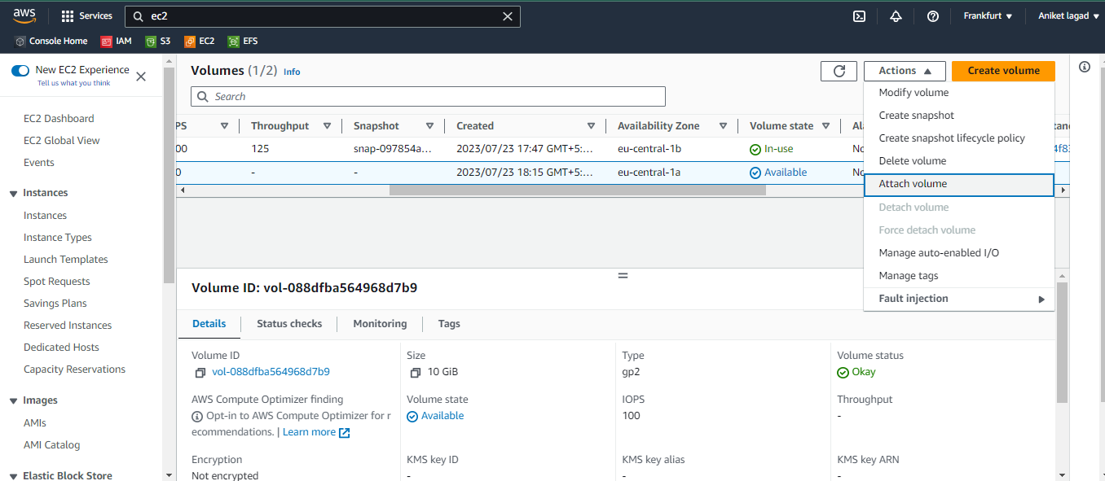

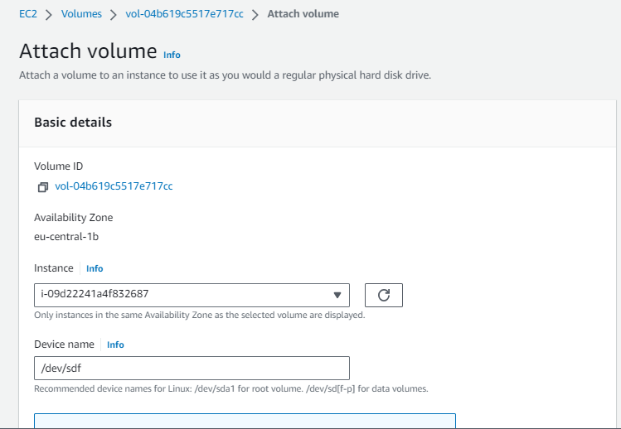

Step 6:-

Now get that instance access on third-party app and make it make it usable as additional storage by creating its partition.

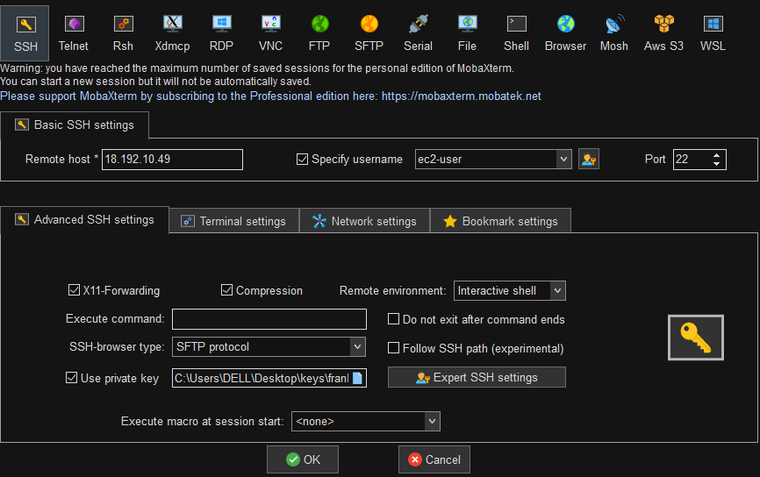

Step 7:-

Now run a command lsblk to see disk is attached or not. 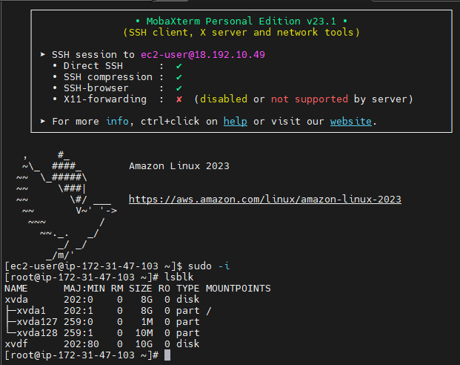

Step 8:-

After that run a command fdisk /dev/xvdf and create a partition.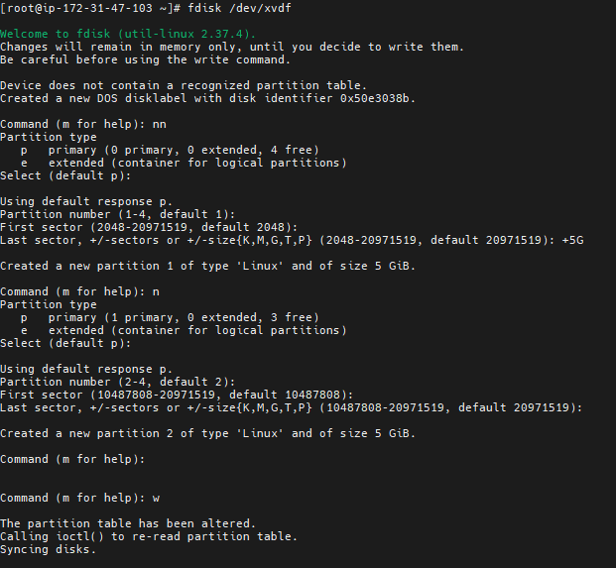

Step 9:-

Now you want to gave its partition file system to mount it. By run command mkfs.

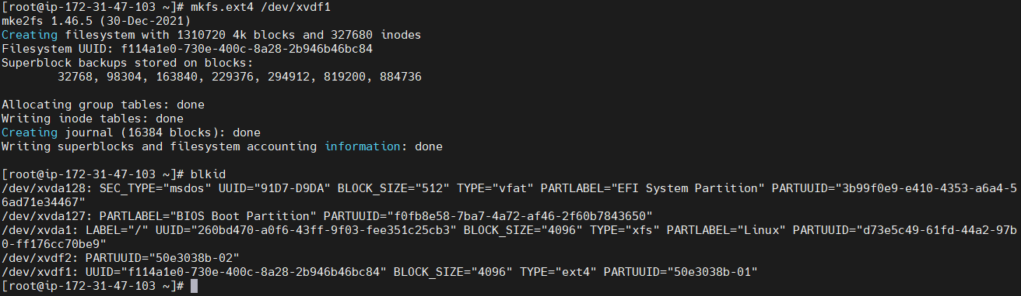

Step 10:-

Now gave it permanent mount by edit configuration file of /etc/fstab.

See following images to how it create.



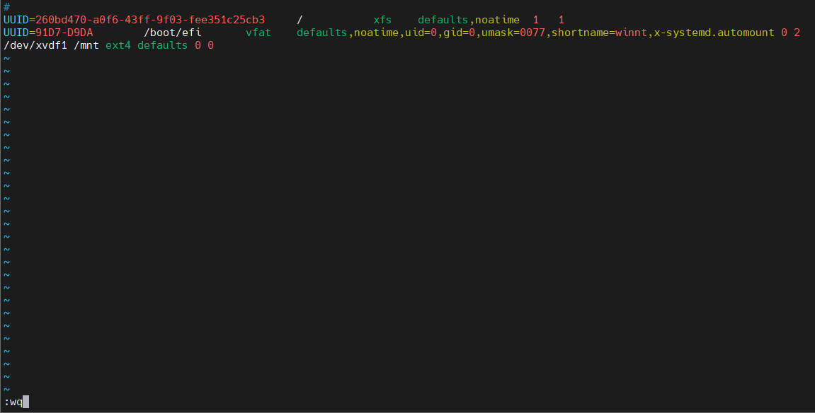

Step 11:-

Now your partition is mounted see following image .

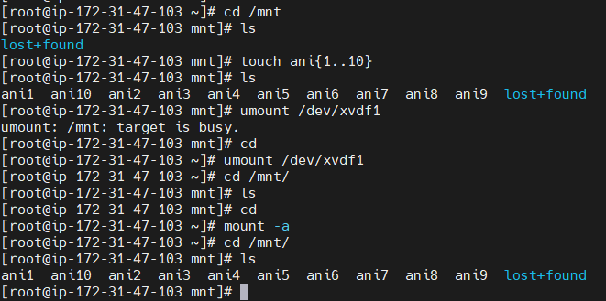

Q.4) VPC and Subnet Configuration:

Create a Virtual Private Cloud (VPC).

Create multiple subnets, public and private, within the VPC.

Configure the route tables and internet gateway to enable internet access for instances in the public subnet.

Launch EC2 instances in both the public and private subnets and verify network connectivity.

🡺

Q.5) Implementing Load Balancer:

Set up an Application Load Balancer (ALB) or Network Load Balancer (NLB).

Register EC2 instances with the load balancer to distribute traffic evenly.

Configure health checks to monitor the health of instances and automatically remove unhealthy instances from the load balancer.

Test the load balancer's functionality by accessing the application through its DNS name.

🡺

Step 1:-

Login to aws account and go to ec2 service.

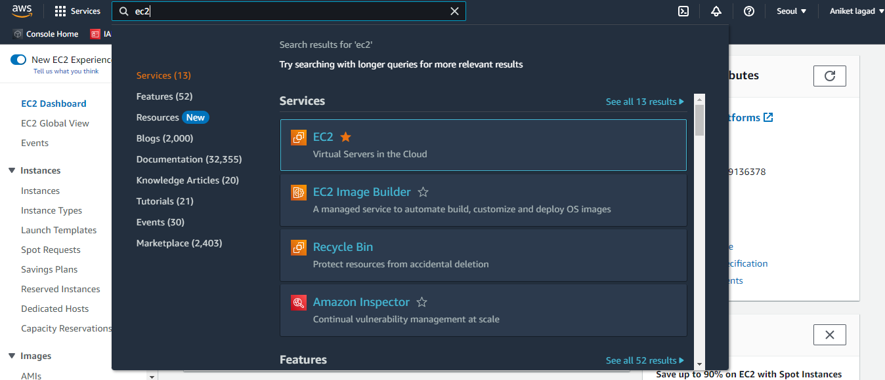

Step 2 :-

Now you have to launch a instance with page hosting by different hosting directories.

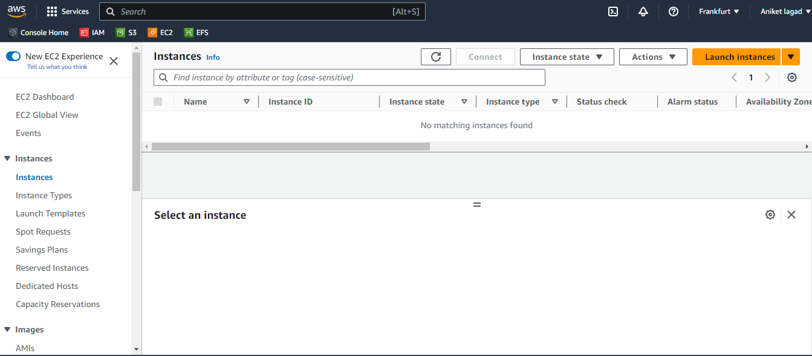

Step 3:-